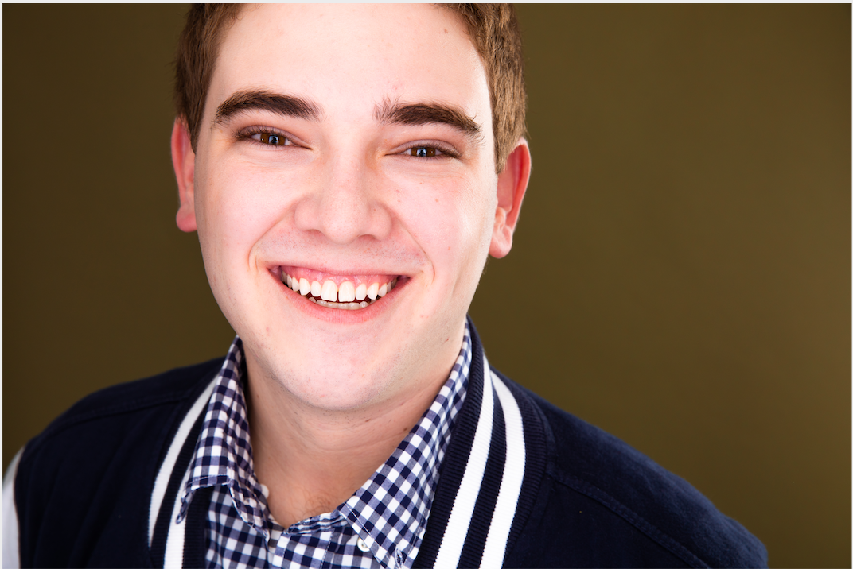
Nolan Atterbury
Email- IAmNolanAtterbury@gmail.com
Phone Number- (551) 227-7054
Height- 6’1”
Weight- 215
Voice- Baritone/ Tenor

THEATRE:
Blood | Lead (Dan) | Dir. Alex Church-Gonzales
RENT | Lead (Mark) | Dir. Kevin Hauge
Bloody Bloody Andrew Jackson | Lead (Andrew) | Sobrato Theater/ Peter Canavese
A Midsummer Night’s Dream | Supporting (Bottom) | Untitled Shakespeare Project
Much Ado About Nothing | Supporting (Don Pedro) | Sobrato Theater/ Russ Marcel
Of Mice and Men | Supporting (Candy) | Sobrato Theater/ Jeremy Lum
A Game | Lead (Edson) | Dir. Sarah Hurley
FILM:
Change of Heart | Lead | Dir. Sid Iyer
Ext. Life Continuous | Lead | Dir. Joey Pereira
All of the Above | Supporting | Dir. Joey Pereira

TRAINING:
BA Acting- International Performance Ensemble, Pace University
Shakespeare | Edward Berkley
Meisner | Sebastian Tudores
Stage Combat | Michael Chin
Script Analysis, Auditioning | Thomas Keith
Stanislavsky, Hagen | Cosmin Chivu
Devised Theater/ Lecoq | Adrienne Kapstein
Meyerhold | Jon Froelich
Fitzmaurice | Josh Moser

SPECIAL SKILLS:
Balloon Animals, Proper British Accent, Double Jointed Shoulder, Speak Latin, Whistle, Basic Pass in Knife Combat (2019) by the SAFD, Recommended Pass in Unarmed Combat (2019) and Rapier and Dagger (2018) by the SAFD, Science Fiction Fanatic, Dungeons and Dragons DM and Player,

